K-Pop Market Research Database

Mahima Tak ([MAHIMA.TAK@BARUCHMAIL.CUNY.EDU](mailto:MAHIMA.TAK@BARUCHMAIL.CUNY.EDU))

Rachana Somani ([RACHANA.SOMANI@BARUCHMAIL.CUNY.EDU](mailto:RACHANA.SOMANI@BARUCHMAIL.CUNY.EDU))

Mariya Mithaiwala ([MARIYA.MITHAIWALA@BARUCHMAIL.CUNY.EDU](mailto:MARIYA.MITHAIWALA@BARUCHMAIL.CUNY.EDU))

Roger Jantzen ([ROGER.JANTZEN@BARUCHMAIL.CUNY.EDU](mailto:ROGER.JANTZEN@BARUCHMAIL.CUNY.EDU))

Vaughn Fortier Shultz ([VAUGHN.FORTIERSHULTZ@BARUCHMAIL.CUNY.EDU](mailto:VAUGHN.FORTIERSHULTZ@BARUCHMAIL.CUNY.EDU))

CIS 9340, Section 28752 – Prof. Martich

**Tables (Entities and Attributes)**

|  |  |
| --- | --- |
| **Entity (Table Name)** | **Attributes** |
| Artist (Individual) | Artist ID (PK), Artist Name, Birthday, Hometown, Group ID (FK) |
| Group (Comprised of Multiple Artists) | Group ID (PK), Group Name, Active (True/False) |
| Music Release | Release ID (PK), Release Type (Album/Single/EP), Release title, Date of Release, Length (runtime), Highest Chart Position, Current Chart Position, Sales, Group ID (FK), Distributor ID (FK) |
| Distributors | Distributor ID (PK), Distributor Name, Address, City, State/Territory/Region, Postal Code, Employee ID (FK) |
| Customers | Customer ID (PK), Customer Name, Address, City, State/Territory/Region, Postal Code, Employee ID (FK) |
| Target Markets | Market ID (PK), Market Location, Target Type, Size of Market in $, Employee ID (FK) |
| Target Customers | Customer ID (PK), Customer Name, Customer Type, Address, City, State/Territory/Region, Postal Code, Market ID (FK) |
| Employees | Employee ID (PK), Name, Salary, Hiring Date, Address, City, State/Territory/Region, Postal Code |

**Relationship Sentences**

ONE artist belongs to ONE group  
ONE group has ONE to MANY artists

ONE group publishes ONE to MANY music releases  
ONE music release is published by ONE group

ONE music release is distributed by ONE to MANY distributors  
ONE distributor distributes ONE to MANY music releases

ONE distributor provides updates to ZERO TO MANY employees  
ONE employee co-ordinates with ZERO TO MANY distributors

ONE target market services ONE TO MANY target customers  
ONE target customer is served by ZERO TO MANY target markets

ONE target market is served by ZERO to MANY employee  
ONE employee manages/pitches ZERO to MANY target markets

ONE Employee services ONE to MANY customers  
ONE Customer is being serviced by ONE to MANY Employees

**Entity-Relationship Diagram**

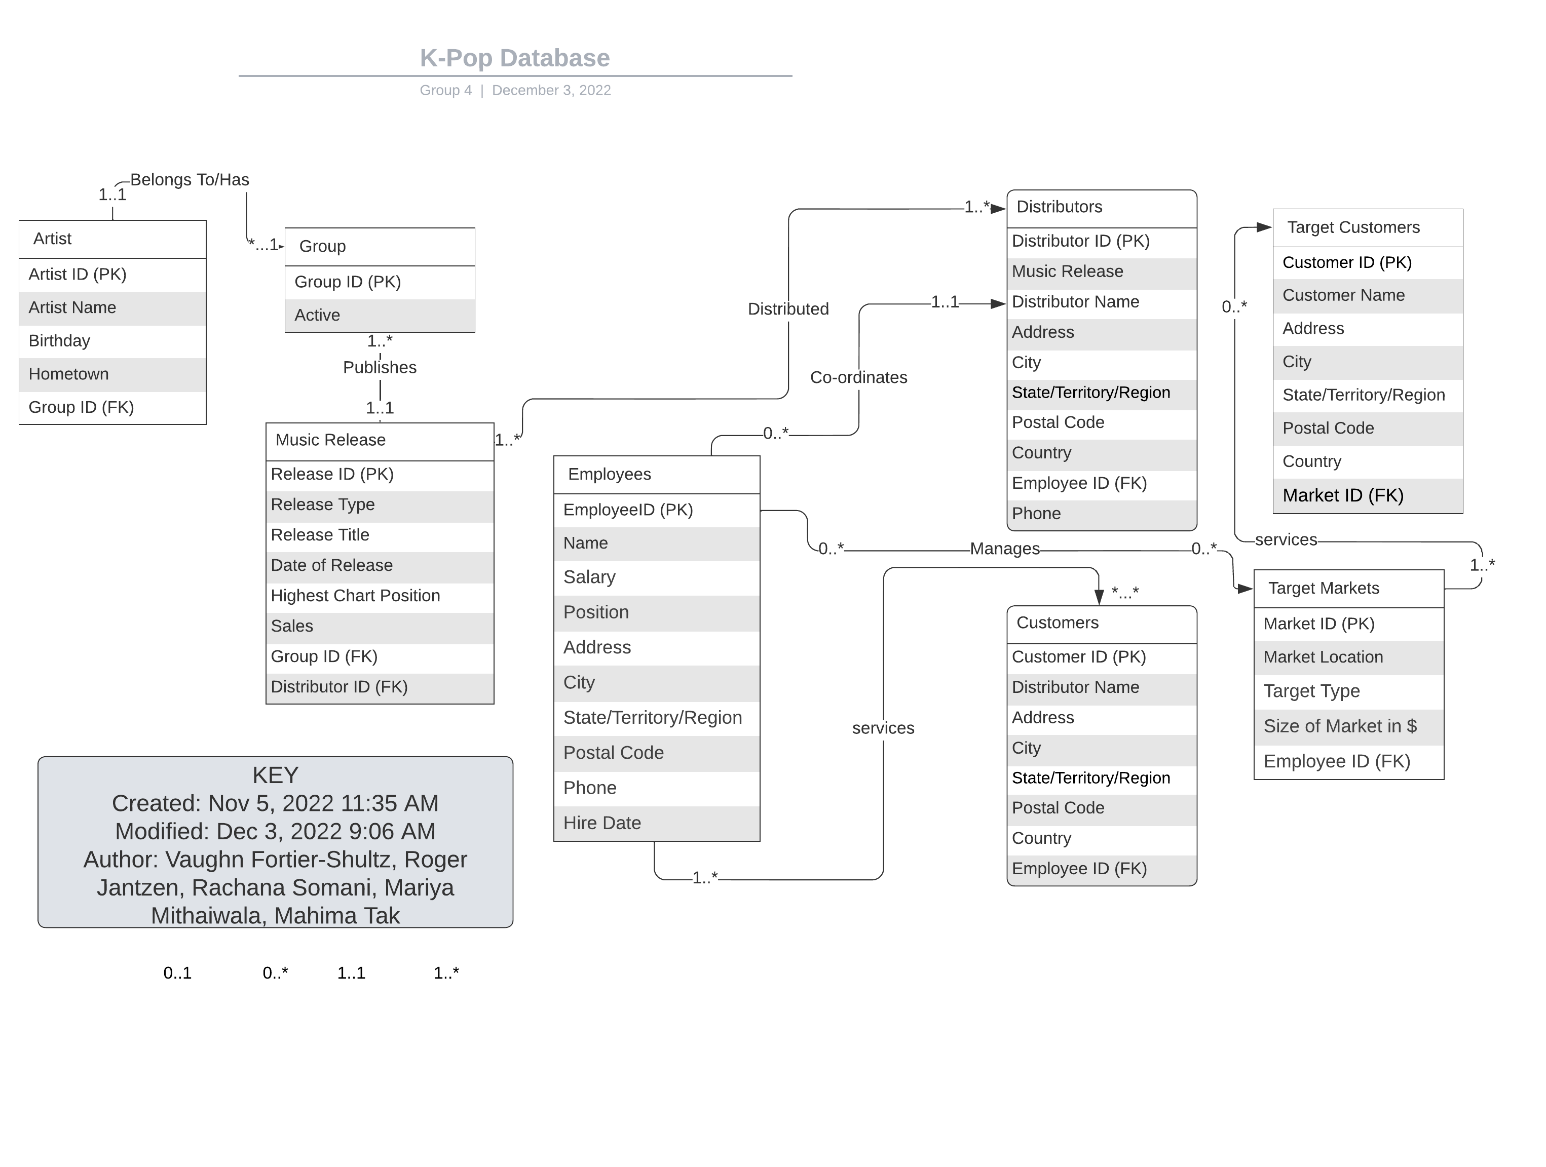

**Overview of Normalization**

The goal of normalization is to move from a graphical model as represented by the Entity-Relationship diagram to a set of relations and then assess whether those relations meet certain criteria. The criteria are defined at each stage of normalization to determine the normalized form of the relations.

**Table of Normalized Relations**

|  |
| --- |
| **ARTIST** (Artist ID (PK), Name, Birthday, Hometown, Group ID (FK)) |

**Checklist of Criteria for Normalized Forms**

|  |  |  |
| --- | --- | --- |
| **Normal Form** | **Criteria** | **Resolved?** |
| **UNF** | A table containing one or more repeating groups | ☑ |
| **1NF** | A relation in which each row and column intersection contains exactly one value | ☑ |
| **2NF** | A 1NF relation with every non-primary-key attribute fully functionally dependent on the primary key | ☑ |
| **3NF** | A 2NF relation with no non-primary-key attribute transitively dependent on the primary key | ☑ |
| **BCNF** | If B is a primary-key attribute and A is not a candidate key, BCNF insists that for a functional dependency A ® B, A must be a candidate key. | N/A |
| **4NF** | A relation is in 4NF if and only if for every nontrivial multivalued dependency A —>> B, A is a candidate key of the relation. | N/A |
| **5NF** | No relations may contain a nontrivial join dependency (JD) without the associated projection including a candidate key of the original relation | N/A |

**Table of Normalized Relations**

|  |
| --- |
| **GROUP** (Group ID (PK), Name, Active) |

**Checklist of Criteria for Normalized Forms**

|  |  |  |
| --- | --- | --- |
| **Normal Form** | **Criteria** | **Resolved?** |
| **UNF** | A table containing one or more repeating groups | ☑ |
| **1NF** | A relation in which each row and column intersection contains exactly one value | ☑ |
| **2NF** | A 1NF relation with every non-primary-key attribute fully functionally dependent on the primary key | ☑ |
| **3NF** | A 2NF relation with no non-primary-key attribute transitively dependent on the primary key | ☑ |
| **BCNF** | If B is a primary-key attribute and A is not a candidate key, BCNF insists that for a functional dependency A ® B, A must be a candidate key. | N/A |
| **4NF** | A relation is in 4NF if and only if for every nontrivial multivalued dependency A —>> B, A is a candidate key of the relation. | N/A |
| **5NF** | No relations may contain a nontrivial join dependency (JD) without the associated projection including a candidate key of the original relation | N/A |

**Table of Normalized Relations**

|  |
| --- |
| **MUSIC RELEASE** (Release ID (PK), Type, Title, Release Date, Runtime, Highest Chart Position, Current Chart Position, Sales, Group ID (FK), Distributor ID (FK)) |

**Checklist of Criteria for Normalized Forms**

|  |  |  |
| --- | --- | --- |
| **Normal Form** | **Criteria** | **Resolved?** |
| **UNF** | A table containing one or more repeating groups | ☑ |
| **1NF** | A relation in which each row and column intersection contains exactly one value | ☑ |
| **2NF** | A 1NF relation with every non-primary-key attribute fully functionally dependent on the primary key | ☑ |
| **3NF** | A 2NF relation with no non-primary-key attribute transitively dependent on the primary key | ☑ |
| **BCNF** | If B is a primary-key attribute and A is not a candidate key, BCNF insists that for a functional dependency A ® B, A must be a candidate key. | ☑ |
| **4NF** | A relation is in 4NF if and only if for every nontrivial multivalued dependency A —>> B, A is a candidate key of the relation. | ☑ |
| **5NF** | No relations may contain a nontrivial join dependency (JD) without the associated projection including a candidate key of the original relation | ☑ |

**Table of Normalized Relations**

|  |
| --- |
| **DISTRIBUTORS** (Distributor ID (PK), Distributor Name, Address, City, State/Territory/Region, Postal Code, Employee ID (FK) |

**Checklist of Criteria for Normalized Forms**

|  |  |  |
| --- | --- | --- |
| **Normal Form** | **Criteria** | **Resolved?** |
| **UNF** | A table containing one or more repeating groups | ☑ |
| **1NF** | A relation in which each row and column intersection contains exactly one value | ☑ |
| **2NF** | A 1NF relation with every non-primary-key attribute fully functionally dependent on the primary key | ☑ |
| **3NF** | A 2NF relation with no non-primary-key attribute transitively dependent on the primary key | ☑ |
| **BCNF** | If B is a primary-key attribute and A is not a candidate key, BCNF insists that for a functional dependency A ® B, A must be a candidate key. | N/A |
| **4NF** | A relation is in 4NF if and only if for every nontrivial multivalued dependency A —>> B, A is a candidate key of the relation. | N/A |
| **5NF** | No relations may contain a nontrivial join dependency (JD) without the associated projection including a candidate key of the original relation | N/A |

**Table of Normalized Relations**

|  |
| --- |
| **CUSTOMERS** (Customer ID (PK), Customer Name, Address, City, State/Territory/Region, Postal Code, Employee ID (FK)) |

**Checklist of Criteria for Normalized Forms**

|  |  |  |
| --- | --- | --- |
| **Normal Form** | **Criteria** | **Resolved?** |
| **UNF** | A table containing one or more repeating groups | ☑ |
| **1NF** | A relation in which each row and column intersection contains exactly one value | ☑ |
| **2NF** | A 1NF relation with every non-primary-key attribute fully functionally dependent on the primary key | ☑ |
| **3NF** | A 2NF relation with no non-primary-key attribute transitively dependent on the primary key | ☑ |
| **BCNF** | If B is a primary-key attribute and A is not a candidate key, BCNF insists that for a functional dependency A ® B, A must be a candidate key. | N/A |
| **4NF** | A relation is in 4NF if and only if for every nontrivial multivalued dependency A —>> B, A is a candidate key of the relation. | N/A |
| **5NF** | No relations may contain a nontrivial join dependency (JD) without the associated projection including a candidate key of the original relation | N/A |

**Table of Normalized Relations**

|  |
| --- |
| **TARGET MARKETS** (Market ID (PK), Market Location, Target Type, Market Size, Employee ID (FK)) |

**Checklist of Criteria for Normalized Forms**

|  |  |  |
| --- | --- | --- |
| **Normal Form** | **Criteria** | **Resolved?** |
| **UNF** | A table containing one or more repeating groups | ☑ |
| **1NF** | A relation in which each row and column intersection contains exactly one value | ☑ |
| **2NF** | A 1NF relation with every non-primary-key attribute fully functionally dependent on the primary key | ☑ |
| **3NF** | A 2NF relation with no non-primary-key attribute transitively dependent on the primary key | ☑ |
| **BCNF** | If B is a primary-key attribute and A is not a candidate key, BCNF insists that for a functional dependency A ® B, A must be a candidate key. | ☑ |
| **4NF** | A relation is in 4NF if and only if for every nontrivial multivalued dependency A —>> B, A is a candidate key of the relation. | ☑ |
| **5NF** | No relations may contain a nontrivial join dependency (JD) without the associated projection including a candidate key of the original relation | ☑ |

**Table of Normalized Relations**

|  |
| --- |
| **TARGET CUSTOMERS** (Customer ID (PK), Customer Name, Customer Type, Address, City, State/Territory/Region, Postal Code, Market ID (FK)) |

**Checklist of Criteria for Normalized Forms**

|  |  |  |
| --- | --- | --- |
| **Normal Form** | **Criteria** | **Resolved?** |
| **UNF** | A table containing one or more repeating groups | ☑ |
| **1NF** | A relation in which each row and column intersection contains exactly one value | ☑ |
| **2NF** | A 1NF relation with every non-primary-key attribute fully functionally dependent on the primary key | ☑ |
| **3NF** | A 2NF relation with no non-primary-key attribute transitively dependent on the primary key | ☑ |
| **BCNF** | If B is a primary-key attribute and A is not a candidate key, BCNF insists that for a functional dependency A ® B, A must be a candidate key. | N/A |
| **4NF** | A relation is in 4NF if and only if for every nontrivial multivalued dependency A —>> B, A is a candidate key of the relation. | N/A |
| **5NF** | No relations may contain a nontrivial join dependency (JD) without the associated projection including a candidate key of the original relation | N/A |

**Table of Normalized Relations**

|  |
| --- |
| **EMPLOYEES** (Employee ID (PK), Name, Salary, Hiring Date, Address, City, State/Territory/Region, Postal Code, HireDate) |

**Checklist of Criteria for Normalized Forms**

|  |  |  |
| --- | --- | --- |
| **Normal Form** | **Criteria** | **Resolved?** |
| **UNF** | A table containing one or more repeating groups | ☑ |
| **1NF** | A relation in which each row and column intersection contains exactly one value | ☑ |
| **2NF** | A 1NF relation with every non-primary-key attribute fully functionally dependent on the primary key | ☑ |
| **3NF** | A 2NF relation with no non-primary-key attribute transitively dependent on the primary key | ☑ |
| **BCNF** | If B is a primary-key attribute and A is not a candidate key, BCNF insists that for a functional dependency A ® B, A must be a candidate key. | N/A |
| **4NF** | A relation is in 4NF if and only if for every nontrivial multivalued dependency A —>> B, A is a candidate key of the relation. | N/A |
| **5NF** | No relations may contain a nontrivial join dependency (JD) without the associated projection including a candidate key of the original relation | N/A |